Problems of bentonite rebonding of synthetic system sands in turbine mixers

Fedoryszyn Aleksander, Zych Jerzy, Rudy Czesław

Abstract
Turbine (rotor) mixers are widely used in foundries for bentonite rebonding of synthetic system sands. They form basic equipment in modern sand processing plants. Their major advantage is the short time of the rebond mixing cycle.
Until now, no complete theoretical description of the process of mixing in turbine mixers has been offered. Neither does it seem reasonable to try to adapt the theoretical backgrounds of the mixing process carried out in mixers of other types, for example, rooler mixers [1], to the description of operation of the turbine mixers. Truly one can risk the statement that the individual fundamental operations of mixing in rooler mixers, like kneading, grinding, mixing and thinning, are also performed in turbine mixers. Yet, even if so, in turbine mixers these processes are proceeding at a rate and intensity different than in the roller mixers. The fact should also be recalled that the theoretical backgrounds usually relate to the preparation of sand mixtures from new components, and this considerably restricts the field of application of these descriptions when referred to rebond mixing of the system sand. The fundamentals of the process of the synthetic sand rebonding with bentonite require determination and description of operations, like disaggregation, even distribution of binder and water within the entire volume of the rebonded sand batch, sand grains coating, binder activation and aeration.
This study presents the scope of research on the sand rebonding process carried out in turbine mixers. The aim has been to determine the range and specific values of the designing and operating parameters to get optimum properties of the rebonded sand as well as energy input in the process.
Introduction
The great popularity of synthetic sands with bentonite is mainly due the fact that they can be recycled and reused in 95÷98% [3]. The used sand, after having been separated from the castings, is tempered and reconditioned with batches of new sand, bentonite and a lustrous carbon carrier.
Rebonding of the used sand consists in:
- disintegration of lumps and agglomerates formed after the repeated use of system sand,
- uniform distribution of rebonding agent within the whole volume of the rebonded sand batch,
- coating of the sand grains with binding material added for the sand rebonding,
- activation of coating.
Compared with the starting sand mixture prepared from new materials only, the used sand has different granular composition. The degree to which the granulometry of the sand changes depends on the following factors: sand composition, mould making technology, thermal load on moulds, preparation procedure adopted by the foundry, etc. The granulometry of the sand composition assigned for rebonding is characterised by a higher content of coarse grain fractions. The grain size analyses have revealed the prevalence of the sand lumps that are disintegrated in a turbine mixer made by PPP Technical (Fig.1).
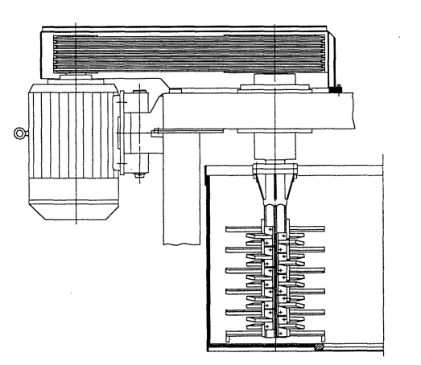
Rys.1. Schemat i widok wirnika mieszarki wirnikowejl
Fig.1. Schematic representation of a turbine mixer and its rotor
Mixing process should result in deformation and disintegration of the agglomerates, and it should provide an even distribution of clay-water slurry on the sand grains surface.
During mixing of the tempered sand, the particles of clay are sticking to the surface of the grains, usually as lumps or agglomerates. The grain coating process is achieved through the elementary effects of compression, tension and shearing acting on a complex of the sand grains joined together with agglomerates of the binding agent. On compression, the sand grains are forced into the agglomerates of clay-water slurry. After breaking, some of this slurry still remains deposited on each of the grains. In the sands in which the binding agent is a mixture of clay and water, the destruction of bond is usually achieved by overcomig the forces of cohesion that exist between the layers of the binding agent.
Coating of sand grains with a layer of the wet clay requires repeated action of deformation due to the effect of compressive, tensile and shear stresses [2,9]. These elementary effects are obtained in mixers of different designs and occur at various mixing rates. The number of the elementary effects depends on the mixing time and on the process run characterisitic of each mixing unit. Simple tests that consist in cross-wise compression (alternately in perpendicular directions) of the sand batches placed in a ball-like rubber container have proved that after each next cycle the sand compression strength R_{c}^{w}, resulting from the degree to which the sand grains have been coated with clay-water composition, increases [4] and after 300 operations acquires a sufficiently high level.
In the technical specifications of edge runner mixers and speedmullers, the number of the elementary operations is in the range of 100÷300; in paddle mixers this number raises to 760 operations [1,8]. In the case of turbine mixers where the rotational speed of the turbine is 450÷600 rev/min and the mixing cycle is 90÷120 s, the number of the elementary operations is comprised within the range of 900÷1200 [5].
Mixing is made easier by changes in the absolute viscosity of clay-water system – the effect that accompanies the repeated shearing. The rate and scope of these changes depend on the shear rate and time. The higher is the shear rate and the longer is the time of shearing, the lower is the instantaneous viscosity of the bentonite sand [9].
During rebond mixing carried out in turbine mixers, the process of activation occurs. It consists in disclosing the new layers of binder. For example, a layer of the thickness of 3,5 μm (with an average sand grains size R_{z} =0,11 mm and the binding clay content in the sand G=8%) holds about 60 particles of montmorillonite, or 720 of its elementary packets [3,6]. The possibilities of activation of the binding agent are enormous, considering the fact that each elementary effect of the grains getting separated from each other acts on all the elementary packets of montmorillonite. The clay binder is re-arranging its thixotropic structure and the rheological properties are changing. This step is a part of the complex process of activation.
Scope and aim of the research
The author’s own investigations also confirm changes in granulometry of the return sand assigned for rebonding. Compared to the same new sand, the return sand directed to rebond mixing is characterised after each next cycle by a higher content of the coarse-grain fractions.
High-rate disintegration of lumps is achieved due to the backward rotational movement of the rotor and mixer pan. This kinematic pair is characterised by high mixing process dynamics owing to the fact that the sand flowing onto the turbine (fed by the rotating pan) is by this turbine thrown away at a high velocity in direction opposite to the direction of the pan movement. The sand is continuously fed by the rotating pan under the turbine which makes it heap up, especially in front of the turbine and around it.
During rebond mixing it is necessary to create the conditions that would promote an intense disintegration but mainly of the particles of a large size. This aim is achieved by the turbine design such that while rotating it creates the conditions promoting separation of the grains of different sizes. The conditions that provoke the sand fluidisation enable creating a zone of intense disintegrating effect acting on the grains of the size d_{i} larger than the boundary size d_{z}. Under these conditions, the grains of d_{i} ≤d_{z} are not subjected to the disintegrating effect, due to which their excessive disintegration is avoided. The boundary grain size d_{z} is dictated by process technology, while time necessary to obtain this size results from the design and operating parameters (the size and geometry of the rotor, the time of mixing, etc.). Examples of the results obtained during research described in [5] have indicated that with the turbine rotations of 265÷275 1/min and the rotating blades inclined at an angle of about 40⁰, a set of the grains of d_{i} ≤d_{z} will be fluidised. Under these conditions, only the sand lumps with the grain size of d_{z}=0,2 mm are disintegrated without the unnecessary increase in the content of fine-grain fractions. So, fluidising enables selective disintegration. It has also been proved that higher rotational speed of turbine and longer mixing time make the sand disaggregation process more and more dynamic [7].
The dynamics of the mixing process favours the effective distribution of the rebonding agents within the whole volume of the processed sand batch. A measure of the mixing efficiency of components in the rebonded moulding sand and of the coating distribution on the sand grains, where this coating is formed of a film of the added binder, is the sand strength coefficient S_{δ} = s/δ_{śr,} (standard deviation and variance). The symbols denote: δ_{śr} –the value of the sand green compression strength R_{c}^{w} determined as a mean calculated from the measurements taken on the specimens from different areas of the mixer pan. The value of the compression strength (R_{c}^{w}) and its stability have been chosen as basic parameters in evaluation of the mixing process, since they both depend on the degree of effective binder distribution on the sand grains surface [5]. When binder is distributed in a uniform manner, the highest values of R_{c}^{w} are obtained without any significant deviations. Some values of the mixing degree S_{δ} are shown as examples in Figure 2. The values of S_{δ} refer to the results stated by literature [11] and to the results of the tests carried out on a pilot turbine mixer of n_{w} = 700 rev/min and on an edge runner mixer.
Rys.2. Wartości wskaźnika zmieszania składników masy syntetycznej z bentonitem [9]
Fig.2. Values of the mixing factor for the components of synthetic sand with bentonite [9]
Czas mieszania – mixing time
Stopień zmieszania – mixing degree
Mieszarka krążnikowa – rooling mixer
Mieszarka wirnikowa – turbine mixer
The high dynamics of the rotor elements operation is raising the sand temperature by about 1÷1,5⁰C/min. [5]. It is recommended to keep the grains jet velocity at a level of 20 m/s, as this can ensure a very intense grains interaction with each other and with the side wall of the mixer pan.
The grains jet velocity is a resultant of the rotor revolutions number. In the majority of cases, the revolutions of a rotor are kept constant throughout the whole rebond mixing process. The only exception is the concept of variable speeds of the rotor and the pan. Mixers like RTM and Rotomax [12] execute mixing process at variable speeds adjustable within the range of n_{w}=400÷570 1/min for the rotor and n_{m}=8,3÷11,3 1/min for the pan. Different values of these speeds are adopted for charging, lumps disintegration, mixing, aeration and discharging. The duration of these operations is also adjustable. This concept of the rebond mixing allows an effective reduction of the process cost and driving power.
Relating the driving power N (kW) to the performance rate W (t/hour) one can calculate the proportionality factor L_{wł} (kJ/kg) that determines work necessary to prepare and rebond a unit mass of sand.
For a mixer of 45 kg capacity of the rebonded sand, the factor L_{wł} was found to be 5 kJ/kg [6]. The said value applies to a mixer with rotating turbine and two sand sweeping devices placed on the mixer bottom and at the pan side wall.
Analysing the data from the catalogue it follows that the anticipated values of this factor are comprised in the range of 7÷12 kJ/kg (MTI and MTP mixers [12]). The values of the specific work in the case of RTM (ROTOMAX) turbine mixers with controlled turbine rotations [12] are as low as 4 kJ/kg and less.
The disintegration of the agglomerates of wet clay and a uniform distribution of the binding agent are difficult in view of high absolute viscosity of the clay-water mixture within the effectively applied values of the clay-water ratio. Yet, due to the elementary effects, shearing included, a reversible process of reconstruction of the internal structure in a sand-clay/water slurry system takes place, reducing with elapsing time the internal friction. The sand mixture is a system unstable in terms of rheology. This is illustrated by changes in the viscosity of a thixotropic system on shearing and when regaining the state of equilibrium (Fig.3). When mixing (shearing) is completed, slow return to the original state takes place. The recovery is slow enough to enable measurements to be taken to describe the course of the proceeding changes.
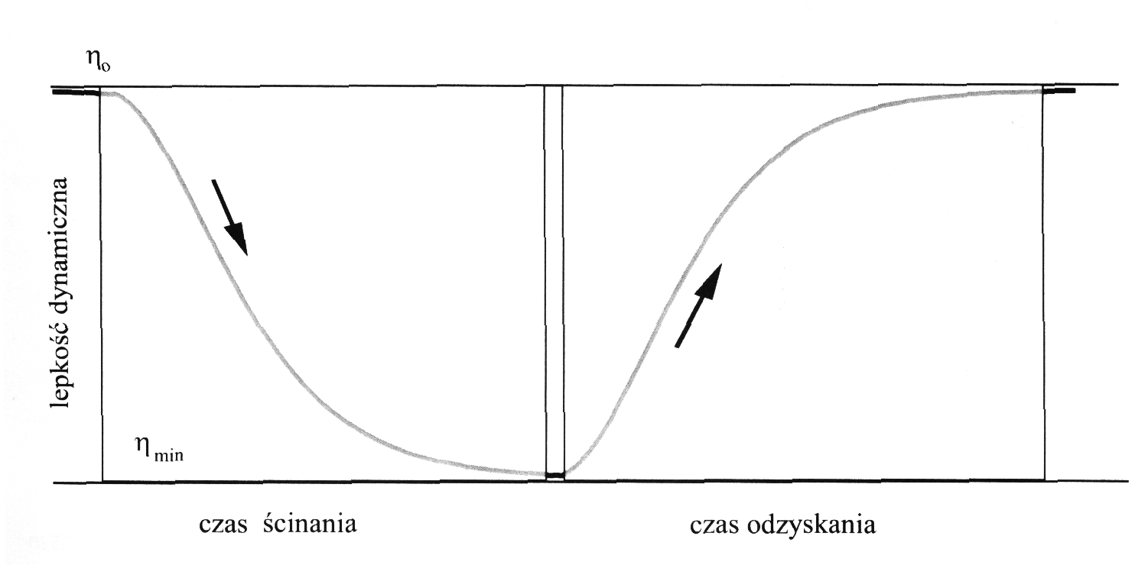
Rys.3. Przebieg zmian lepkości układu tiksotropo wego podczas ścinania i przy powrocie do stanu równowagi (model procesu)
Fig. 3. Viscosity changes in a thixotropic system during shearing and recovery of the equilibrium state (model of the process)
Lepkość dynamiczna – absolute viscosity
Czas ścinania – shearing time
Czas odzyskania – recovery time
Changes in rheological properties of the prepared bentonite sand were evaluated by the method of ultrasonic testing developed by J. Zych [10, 11]. The essence of this technique consists in detemining the value of longitudinal velocity (i.e. propagating only in direction of the axis x) of the wave passing through a sand specimen placed in a probe (Fig.4).
The stand of a pilot mixer and the stand of ultrasonic measurements are shown in Figures 4 and 5, respectively.

Fig.4. Laboratory turbine mixer | Fig.5. Stand for ultrasonic testing of moulding sands

The results of the measurements are shown in Figure 6. During ultrasonic testing of green moulding sand, changes in the dynamic modulus of elasticity are determined. The values of this modulus depend on the elastic features of the base silica sand and on the rheological properties of the binder slurry, including absolute viscosity of this slurry. The elastic behaviour of the silica sand remains stable in the mixture during and after its preparation. Changes in the value of the dynamic modulus observed in the compacted sand specimen (apparent density ~1,55 g/cm³) are due only to the changes that occur in clay-water system. The observed increments in the longitudinal wave velocity and in the sand modulus of elasticity at the stage of the sand recovery start with minimum values observed in sand near the end of its proccessing in a mixer.
Figure 6 shows the results of the ultrasonic measurements taken in specimens of the sand compacted in a test probe directly after it has been prepared. The test sand was prepared in a turbine mixer with mixing proceeding at a rate of 800 rev/min and 360 rev/min. The time of mixing was identical in both cases. Thus prepared sands were subjected to ultrasonic tests; the degree of the specimen compaction was identical in both cases – the apparent density in both cases was 1,52 g/cm³. An analysis of the measurements that in the presented examples are of a contributive nature only enables drawing the first but still quite important conclusions. High rate shearing results in a more “in-depth” reconstruction of the structure, which during the sand maturing is revealed as more pronounced changes in both the wave velocity (Fig. 6) and modulus of the sand dynamic elasticity (Fig. 7). The investigations are confirmed by earlier results obtained for the same bentonite slurries and described in [10 and 11]. These sands will have other technological properties, strength, compactability and flowability. Studies in this scope are to be continued.
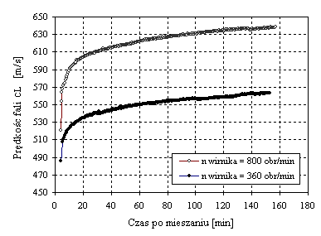
Rys.6. Zmiana prędkości propagacji podłużnej fali ultradźwiękowej w masie wilgotnej po wykonaniu mieszania w mieszarce wirnikowej
Fig.6. Changes in propagation rate of longitudinal ultrasonic waves in the green sand after mixing in turbine mixer
Prędkość fali – wave velocity
Czas po mieszaniu – time after mixing
Rotor rpm = 800
Rotor rpm = 360

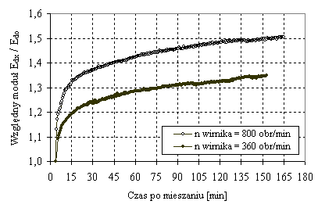
Rys. 7. Zmiana wartości względnego modułu dynamicznej sprężystości masy wilgotnej po po wykonaniu mieszania w mieszarce wirnikowej
Fig. 7. Changes in relative dynamic modulus of elasticity of the green sand after mixing in turbine mixer
Prędkość fali – wave velocity
Czas po mieszaniu – time after mixing
Rotor rpm = 800
Rotor rpm = 360

Summary
The volume of the rebonding materials is relatively small compared with the volume of the rebonded sand. Therefore the properties of the rebonded sand depend to a great extent on the performance efficiency of the elements and units operating in a turbine mixer.
The advantage of turbine mixers is the shorter time of technological cycle due to intensification of mechanical effect acting on the sand and the possibility of charging large batches of rebonded sand to the mixer.
The sand rebonding efficiency depends, first and foremost, on how well the return sand is prepared for rebonding and on its processing in turbine mixer. What is mainly needed is disaggregration of the sand carried out until monograins of the required size are obtained. Avoiding excessive grains disintegration on mixing demands carrying out the process under the conditions when the sand layer is kept in a fluidised state, which is obtained by choosing proper configuration, spacing, size and orientation of the rotor blades as well as their rotational speed.
The design and performance parameters of the rotor influence also the course and output of the remaining elementary operations, i.e. mixing, distribution of sand components and activation, including the thixotropy of the binding material.
The work used for preparation of a batch of the sand and for producing in this sand the required properties is comprised in the range of 4 ÷ 12 kJ/kg. The lower level refers to mixers with adjustable variable speed of both the pan and turbine, depending on the process stage.
Of great significance are the rheological properties of binding material, i.e. of the clay-water slurry. Reducing the absolute viscosity of this material confers to the sand higher fluidity, facilitates building of the well formed bridges joining the sand grains, which consequently results in an increase of the sand strength after its compaction in mould. The performed operations improve the conditions of mixing the sand components, the improvement being mainly due to changes taking place in the clay-water system.
The study was performed under the AGH scientific-research project No. 10.10.170.138
References
- Bodzoń L., Dańko J., Żurawski L.: The fundamentals of foundry machines theory. Machines for preparation of moulding sands and moulding materials, Podstawy teorii maszyn odlewniczych. Maszyny do przygotowywania materiałów i mas formierskich. AGH Brochure No. 919. Kraków, 1984.
- Fedoryszyn A., Rudy Cz.: Parameters and Processes of Synthetic Sand Rebonding in Turbine Mixers. Zjawiska i parametry procesu odświeżania syntetycznej masy formierskiej w mieszarkach wirnikowych. Archives of Metallurgy and Materials. Polish Academy of Sciences. Committee of Metallurgy, Institute of Metallurgy and Materials Science. Vol. 53, 3/2007, s. 415- 421
- Flemming E., Lewandowski J.L.: Modern moulding materials and their rational management. Nowoczesne materiały formierskie z punktu widzenia racjonalnej gospodarki materiałowej. Przegląd Odlewnictwa, nr 4, 1995, s. 131
- Iwakin R.I.: Mechanizm i kinetyka procesja obwołakiwanija smiesziwanii piesczano-glinistych formowocznych materiałow. Litiejnoje Proizwodstwo, nr.10, 1982, s. 24
- Jerszow M. Ju., Treszczalin A.W.: Opyt razrabotki i oswojenia smiesitielja formowocznych materiałow. Litiejnoje Proizwodstwo, nr.11, 2000, s. 12
- Jerszow M.Ju.: Rol aktiwacji w processie prigotowlenija formowocznych smiesiej. Proceedings of the International Scientific-Technical Conference „Progressiwnyje technologiczeskije processy i oborudowanie w litiejnom proizvodstwie. MAMI, Moscow, 2002, s 27÷32.
- Krasiczkow W.A.: Issledowanie procesja selektiwnogo pieremiesziwanija edinych pesczano – gliniastych smiesej w centrobieżnom, bezkatkowom smesitiele. Litiejnoje Proizwodstwo, nr.1, 2004 1, s. 32
- Sztefko F. : Development of theoretical backgrounds for the edge runner mixers of continuous operation. Opracowanie podstaw teoretycznych mieszarki krążnikowej o pracy ciągłej. Doctor’s Thesis, Foundry Engineering Faculty AGH. Kraków, 1973, str.3-8.
- Treszczalin A.W., Jerszow M.Ju., Mironow A.W.: Srawnitielnyj analiz beskatkowych smiesitielej. Litiejnoje Proizwodstwo, nr.2, 3, 1998, s. 24
- Zych J. S.: Synthesis of ultrasonic technique applications in analysis of the kinetics of selected processes taking place in moulding materials. Synteza zastosowań techniki ultradźwiękowej w analizie kinetyki wybranych procesów zachodzących w tworzywach formierskich. Dissertations and Monographs 163. Uczelniane Wydawnictwa naukowo-Dydaktyczne. Kraków, 2007
- Zych J.: Ultrasonic testing of the effect of thixotropy in clay-water systems and in green moulding sands. Zjawisko tiksotropii w układach wodno-glinowych i wilgotnych masach formierskich – badania ultradźwiękowe. Archiwum Odlewnictwa. Rocznik 6, Nr 18 (2/2), 2006. PAN – Katowice, s. 465
- Folders and catalogues of companies manufacturing turbine mixers with respective website addresses. Prospekty i materiały katalogowe firm, producentów mieszarek wirnikowych oraz ich strony: www.technical.com.pl; www.dozamet.com.pl; www.eirich.com; www.fondarc.com; www.rhinomachines.com; www.bengioannimachine.com

