Mechanization and automation of synthetic processing moulding sand
Summary
The sand processing plant process including preparation the circulation sand and refresher mixing. Preparation consists of the removal of impurities and cooling the sand directed to refresh.
Cooling sand is currently only in vibration-fluidization cooler. The refresher mixing is performer using the rotor mixers. These devices, which have for years been an the basic equipment the line of sand. These devices, together with tooling to fully ensure the implementation of mechanized and automated processing the sand.
This paper presents examples of projects implemented in the foundries, Czech, Slovak and Polish. In these foundries the basic equipment processing line are units production PPP Technical, company which completely equipped lines, including automatic control systems.
Introduction
In foundries production of castings is done in mold sand, mainly synthetic and , betonite sand, refreshing in next cycles.
This technology is still being developed because of the possibility of use, ever more perfect, mechanization and automation solutions.
Solutions relate the preparation of used sand (circulation) and its refreshing mixing.
Through the use of advanced preparation and refreshing mix sand limited is significant: quantity sand remaining in circulation and the quantity additives refreshing.
A need to apply containers storing sand is being eliminated, and the molding cycle time is reduced to an extent impossible to achieve without changes in the implementation process
Suitable changes also depend upon the gathering moulding sand with excellent technology,
and especially very high transmission. Received by the sand properties are an important factor for improving production efficiency by reducing the number defects. It is also important that there is no need for propellerator before compaction of sand the blow, flux or impulsion method.
The solution moulding line sample
Basic, standard currently equipment of the sand processing plant this is vibration-fluidization cooler and rotor mixer (draw.1 and 2). Sample equipment line implemented in recent years is shown in table 1. Efficiency the basic types of rotor mixers are presented the drawings 3 and 4. Efficiency rotor mixers set going out from capacity the bowl and the adoption of the sand density in the value ρ = 1000 kg/m³ and time mixing τ = 120 s.
Table 1
Sample equipment the of Station preparation Sand
Skoda Auto | SPM - 60
Mlada Boleslav (Czech Republic) | MTI - 2500
GIFF | SPM - 60
Fridland (CzechRepublic) | MTI - 2500
Trinec a.s. | SPM - 80
Trinec (Czech Republic) | RV 24 (Eirich)
Trnava s.r.o. | SPM - 70
Trnava (Czech Republic) | MTI - 3000
Venture Industries | SPM - 45
Grudziądz (Poland) | MTP - 1500
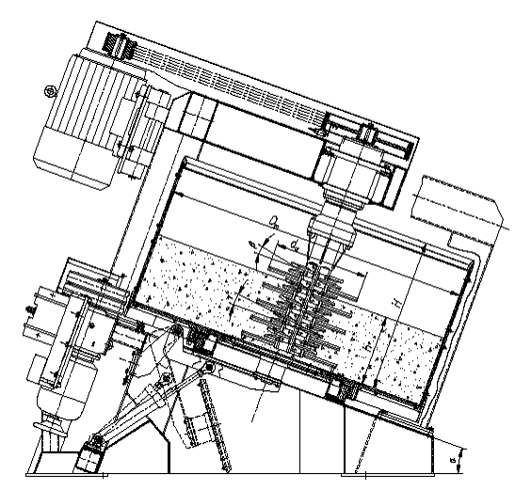 |  | 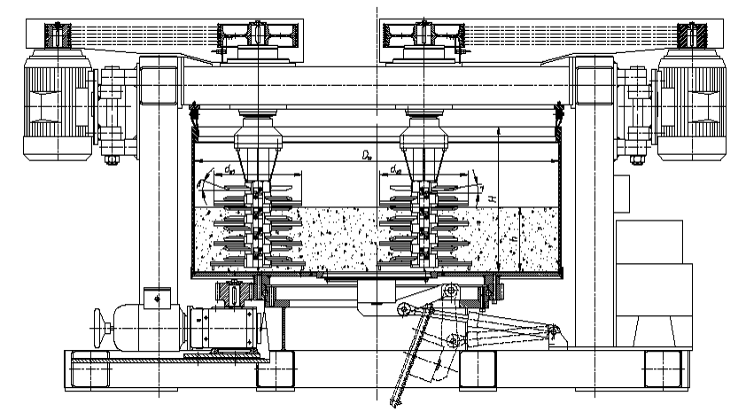
Draw. 1. Scheme mixer MTP |  | Draw. 2. Scheme mixer MTI
Draw.3. Specifics mixers type MTI (horizontal with double rotors)
Draw.4. Capacities of mixers MTP (inclined-single rotor)
The vibration-fluidization cooler carry out the preparation the used sand consisting on reduction of its temperature(draw.5). The cooling process is carried out by evaporation given water purging layer of stepped air sand. Intense cooling conductive a deposit fluxing the deposit due to vibration.
The cooling process is adjustable amount of air given by the fan blowing on the limits of the possibility of air suction. Working conditions require that in the working chamber there was a pressure below atmospheric 10 to 15 mm post H₂O. essential meaning has also the speed of sand flow along of air distributor, which is adjusted the parameters of vibrators, mainly the amplitude of vibration.
Draw.5. Specifics vibration-fluidization cooler
Preparation the used sand beyond cooling, requires purification of impurities, This is achieved using electromagnetic separators and rotary screen. In vibration-fluidization cooler are emitted also the minor impurities that accumulate on the surface of distributor.
Control system of equipment line
The sand after cleaning and cooling is provided into the tank preparation. Similarly, the tanks are collected refreshing additions: bentonite, coal dust, or a mixture.
Dosage set of materials to mixer is equipped in modern units of strain scales, ensure the giving batch about the established, accurate and repeatable quantity. Dosage systems include units (draw.6):
- store tank: used sand, fresh sand, reclaim, add refreshing with levels of probes filling the electronic strain scales of used sand and fresh sand type WTM,
- electronic feeding scale for dusty additions type WTD,
- belt batcher of used sand DT,
- screw feeder of dusty materials DS.
Sand processing plant are equipped with quality sand management systems, developed as its own solutions as well as with the use of world famous companies. Own solution is a RWM system , developed in cooperation of workers PPP Technical and founding department AGH. This system includes a capacitive probe for measuring moisture content by weight, and thermometer, which are placed in a tank of used sand , destined to refresh (draw. 7). Solutions companies in the world is primarily devices German Company Michenfelder Elektrotechnik GmbH & Co KG. These devices are installed at appropriate points system monitors progress of sand processing plant and regulate its basic property, i.e. moisture content and compactibility weight.
Draw. 6. Scheme of equipment the sand processing plant: 1 –weight feeder of use sand and freshener sand , 2 – weight feeder of dusty refreshing additions, 3,4 – belt feeder, 5,6 – screw feeders, 7 – deformeters, 8 – scales meter

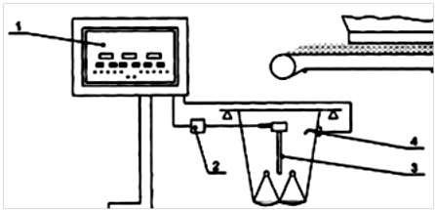
Draw. 7. Moisture control system units and temperature sand: 1 – central device, 2 – measurement generator, 3 – bar capacitor, 4 – temperature sensor
For automatic measurement and control parameters in the moulding sand of devices sand processing plant the German company MICHNENFELDER, cooperates with PPP Technical, offers the most modern moisture control system [5]:
- fully automated moisture control system MICOMP UNI type G-FBK for vibration-fluidization cooler; system guarantees the accuracy of moisture the moulding sand at the exit from the cooler with a tolerance: ±0,2% H₂O,
- moisture control system MICOMP UNI type G-CH for automatic and constant measurement and regulation the moisture moulding sand of turbine mixer; system guarantees the accuracy of moisture the moulding sand at the exit from the mixer with a tolerance: ±0,1% H₂O,
- online sand testing system VEDIMAT-4 for automatic and constant measurement and regulation of parameters the moulding sand; system guaranties degree of compactibility the sand on moulding station with a tolerance: ±2% from set value,
- process control and quality assurance system MiPro to visualization process parameter control sand.
Summary
The presented solution of synthetic and bentonite sand processing plat are now standard.
The basic equipment of preparation the line - vibration-fluidization coolers and sand processing plant- rotary mixer by producing a broad scope productivity and the desired sand properties.
The new technology solution sand processing plant (refreshing mixing) concern automatic moisture control system of moulding sand and technological properties.
Broad sense, supervision is not only to prevent or mitigating emergency situations, consequences of failure, but also the optimization of aimed to obtain the best possible result.
Literature
- Bojanowski W., Woźniak P.: Nowoczesny system zarządzania jakością masy formierskiej. Materiały XII Konferencji Odlewniczej TECHNICAL 2010. TECHNICAL, Wydział Odlewnictwa AGH. Nowa Sól, 2010, s. 49.
- Fedoryszyn A., Rudy Cz., Kaźmierczak J., Novotný J.: Modernizace sléváren – příklad nového vybavení slévárny VENTURE INDUSTRIES. Slévárenství 5-6, 2007, s. 68.
- Fedoryszyn A., Smyksy K.: Analiza pracy chłodziarki wibrofluidyzacyjnej CWFM. Materiały VII Konferencji Odlewniczej TECHNICAL 2004. TECHNICAL, Wydział Odlewnictwa AGH. Nowa Sól, 2004, s. 139.
- Fedoryszyn A., Zych J., Rudy Cz., Novotný J.: Výzkum problematyki ozivování syntetické formovací směsi s bentonitem pří použiti vířivých mísičů. Slévárenství, 11-12, 2009, s. 426.
- Michnenfelder M.: Kompleksowa kontrola jakości masy formierskiej. Materiały VII Konferencji Odlewniczej TECHNICAL 2004. TECHNICAL, Wydział Odlewnictwa AGH. Nowa Sól, 2004, s. 45.
- Rudy Cz.: Analiza procesów zachodzących w mieszarkach wirnikowych. Praca doktorska. Wydział Odlewnictwa AGH. Kraków, 1999
- Rudy Cz., Novotný J., Fedoryszyn A.: Nowoczesna stacja sporządzania masy formierskiej w zlieváreň Trnava s.r.o. – Słowacja. Materiały XI Konferencji Odlewniczej TECHNICAL 2008. TECHNICAL, Wydział Odlewnictwa AGH. Nowa Sól, 2010, s. 25.
- Rudy Cz., Novotný J., Výtvar J.: Stacja przerobu mas formierskich w Škoda Mlada Boleslav – Czechy. Materiały VII Konferencji Odlewniczej TECHNICAL 2004. TECHNICAL, Wydział Odlewnictwa AGH. Nowa Sól, 2010, s. 77.
- Katalogi oraz strony internetowe firm: PPP. Technical Nowa Sól - http://www.technical.com.pl oraz Michenfelder Elektrotechnik GmbH&Co.KG Mainz - http://www.michenfelder.com

